Student Instructions for Accessing MathAS

1. Go to the MathAS URL using your favorite web browser (preferably Firefox):

https://mathas.scottsdalecc.edu/

2. In the Login Screen, click “Force image based display” ‘then “Register as a New Student”

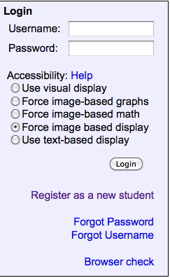

3. Complete the information on the New User Signup page. You will need the following information.

Your Course ID: ____________________________

Your Enrollment Key : ________________________________

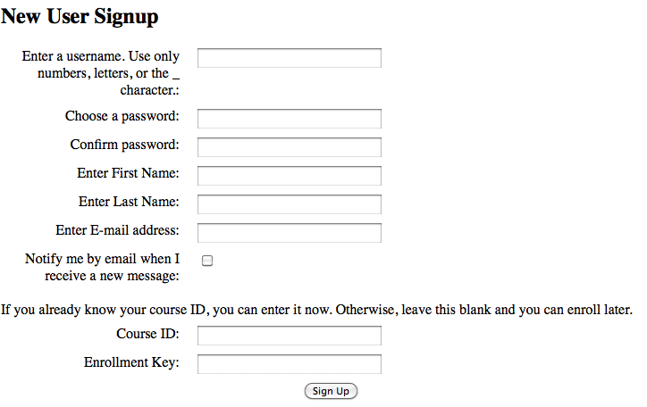
Enter email address.
Click here when finished

4. Return to the MathAS URL https://mathas.scottsdalecc.edu/ and use your login and password to login and access your class. (Use the default of “Force Image Based Display”).

